**Software Requirement Specification**

***Insurance Management***

Document Number: INC-MS-1056

Document Version: 0.1

|  |
| --- |
|  |
|  |

*Proprietary & Confidential*

**Copyright 2016 - 2017 INCEDO INC**. All Rights Reserved. No part of this document may be reproduced, stored in a retrieval system, distributed or transmitted, in any form, or by any means, electronic or otherwise, including photocopying, reprinting, or recording, for any purpose, without the express prior written permission of Incedo Inc.

**REQUESTS** For information requests or for obtaining permission for the use of this work, please submit a written request to: Marketing and Communications, Incedo Inc, Plot No. 248 Udyog Vihar, Phase IV, Gurgaon - 122015. Email: communications@incedoinc.com

**Document Revision History**

|  |  |  |  |  |  |
| --- | --- | --- | --- | --- | --- |
| **S. NO** | **VERSION** | **DATE** | **AUTHOR** | **APPROVAL BY** | **REMARKS** |
| 1 | 0.1 | 9-Oct-2017 | Sumit Jain |  |  |
| 2 |  |  |  |  |  |
| 3 |  |  |  |  |  |
| 4 |  |  |  |  |  |
|  |  |  |  |  |  |

**Table of Contents**

1. Introduction 5

2. Purpose 5

3. Audience 5

4. Project Scope 5

5. Acronyms & Abbreviations 5

6. References 5

7. Specific Requirements 5

# 

# 

# Introduction

This document provides all information of requirements for new application of Insurance Policy Management application to be developed.

# Purpose

Insurance Management provides a one stop solution where customer can see what policy best suits them as per their requirements, suggestions as per the eligibility, buy the best policy, online premium payments and manage all purchased policies at any point of time.

# Audience

1. Anand Kumar (Sponsor)
2. Tajinder Singh (Project Manager)
3. Rajul Shukla (Developer)
4. Dishant Anand (Developer)
5. Sumit Jain (QA)

# Project Scope

The development of this application will be completed in three phases which are explained in detail in section 7.

This application will be an end to end policy management system where-in user can check, buy, service and opt for new schemes as per their criteria. Also, user can do online premium payments as well from his/her user accounts.

# Acronyms & Abbreviations

IMS – Insurance Management System

# References

TBD

# Specific Requirements

## Phase 1:

1. Customer will fill all required details and the policy with premium amount and other details will be shown to the customer
2. The above policy will be shown as per the criteria which will be calculated according to the data provided by customer
3. An e-mail will be sent to customer with the estimations and policy details on the e-mail provided

**Request Form:**

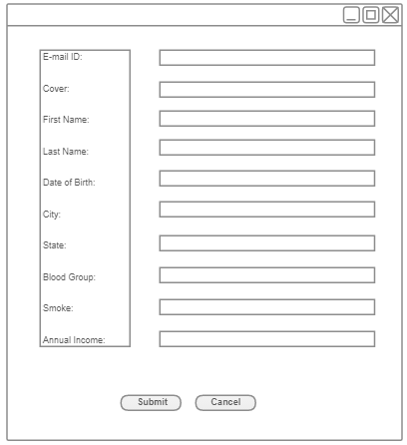

## Phase 2:

1. Customer will be suggested more policies and schemes as per the information provided when customer visits for first time to choose policy
2. Online premium payment facility
3. Premium payment reminders

## Phase 3:

1. Management of enrolled policies
2. Chat bots for service requests